**KALAMSA GUNA PRINCIPLES- DIGGING GALUCOMA CHARTS.**

**BY Dr K.RAVINDER**

Glaucoma is a condition where there is an increased pressure in the anterior eye chamber. This is either due to increased production of Aqueous humour in the aqueous chamber of the eye or blockage of draining of the aqueous humour leading to increased pressure and symptoms of Glaucoma.

Some of the significations of the Second house are: Family, Resources, Wealth, Speech quality, Eye, Family background/lineage, Food, Face, Banks, Savings, Earning capacity etc. In this study charts of native with Glaucoma are studies using the principles of Meena2 Naadi techniques and more precisely the Kalamsa-Guna principles. These charts are exclusively studies with respect to second house related Eye defects (Glaucoma). The karaka for eye, Venus is also analysed.

Searched in astrodata bank using the key word “glaucoma’ has yielded 4 charts.

|  |  |  |  |  |
| --- | --- | --- | --- | --- |
| Sl | Name | Birth details | Place of birth | Category |
| 1 | Harriet Doerr | 8 April 1910 at 04:00 Hrs | Pasadena, CA  USA | Eye (glaucoma), Fiction novels, Vocational award, long life and marriage compatible. |
| 2 | Andrea Bocelli | 22 September 1958 at 05:15 Hrs | Lajatico, Italy | Eye (glaucoma), Loved by all, financial success, Vocalist/Opera, Attorney. |
| 3 | Ray Charles | 23 September 1930 at 00:01 Hrs | Albany, Georgia, USA | Eye (glaucoma) bind from childhood, Drug abuse, Instrumentalist, Liver disease etc. |
| 4 | Jean-Paul Sartre | 21 June 1905  At 18-45 Hrs | Paris, France. | Eye (glaucoma ) Less than 5 feet, unattractive, Abuse of drugs, Atheist, Married late, Top 5% of profession, Nobel prize rejected by him, Novelist, essayist etc. |

1. **Harriet Doerr**

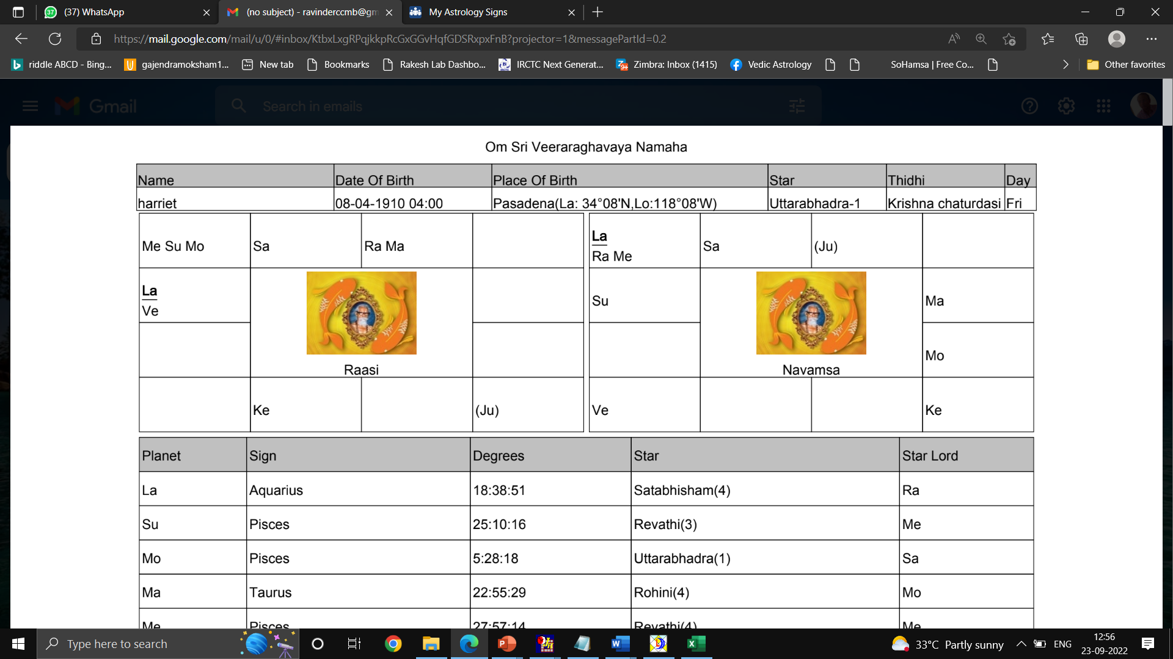

|  |  |  |  |  |  |
| --- | --- | --- | --- | --- | --- |
| **Planet** | **Sign** | **Degrees** | **Nakshatra** | **Qtr** | **Nakshatra Lord** |
| **Ascendant** | Aquarius | 18 0  38’ | Satabisha | 4 | Rahu |
| **Sun** | Pisces | 25 0  10’ | Revathi | 3 | Mercury |
| **Moon** | Pisces | 05 0  28’ | Uttarabhadra | 1 | Saturn |
| **Mars** | Taurus | 22 0  55’ | Rohini | 4 | Moon |
| **Mercury** | Pisces | 27 0  57’ | Revathi | 4 | Mercury |
| **Jupiter** | Virgo | 16 0  00’ | Hastha | 2 | Moon |
| **Venus** | Aquarius | 09 0  56’ | Satabisha | 1 | Rahu |
| **Saturn** | Aries | 02 0  32’ | Ashwini | 1 | Ashwini |
| **Rahu** | Taurus | 08 0  00’ | Krittika | 4 | Sun |
| **Ketu** | Scorpio | 08 0  00’ | Anuradha | 2 | Saturn |

Lagna is Aquarius and lagnapada is in star of Satabisha. Lagna lord Saturn is in 3rd house in its debilitated sign and in star of Ashwini. Venus is posited in lagna in star of Satabisha.

For defect in eye let us analyse the 2nd house lord. Jupiter is posited in Virgo (natural 6th sign of disease) 8th house in the star of Moon (6th lord). There is sign exchange between Jupiter and Mercury (5th and 8th lord). Jupiter is in star of Hastha-2 which is in Kalamsa of Saturn. Saturn is in star of Ketu which becomes Jeeva planet and Ketu is in star of Saturn which becomes Sareera planet. There is sookshma nakshatra parivarthana between Saturn and Ketu. The kalamsa lord Saturn is in star of Ashwini and obtained TTT guna. The Jeeva and Sareera planets of Kalamsa lord are in 6/8 axis. Saturn is in debilitated sign. The kalamsa lord obtained TTT gunas which are transferred to 2nd lord Jupiter (Satwic planet). Thus the 2nd lord is getting unfavourable gunas.

The karaka for eyes Venus (4th and 9th lord, Badhaka) is posited in lagna. Venus is in star of Satabhisha-1 which is kalamsa of Jupiter. Jupiter is in star of Moon which becomes Jeeva planet and Moon is in star of Saturn which becomes Sareera planet. Moon and Saturn are in 2/12 axis. Jeeva planet Moon is in 2nd house conjunct with Sun (7th lord) and Mercury (5th and8th lord). Mercury is in debilitated sign and Sun is in Marnakarna sthan. Sareera planet is in debilitated sign.

The karaka for eye sight and health is Sun. Sun is in Revathi-3 in the Kalamsa of Rahu which obtained RTS gunas. Rahu is in star of Sun which becomes Jeeva planet. Sun is in star of Mercury which becomes Sareera planet. Both Jeeva and Sareera planets are conjunct in 2nd house in their respective unfavourable position. Sun a Rajasic has gained mixed RTS gunas through Tamasic planet Rahu.

1. **Andrea Bocelli**

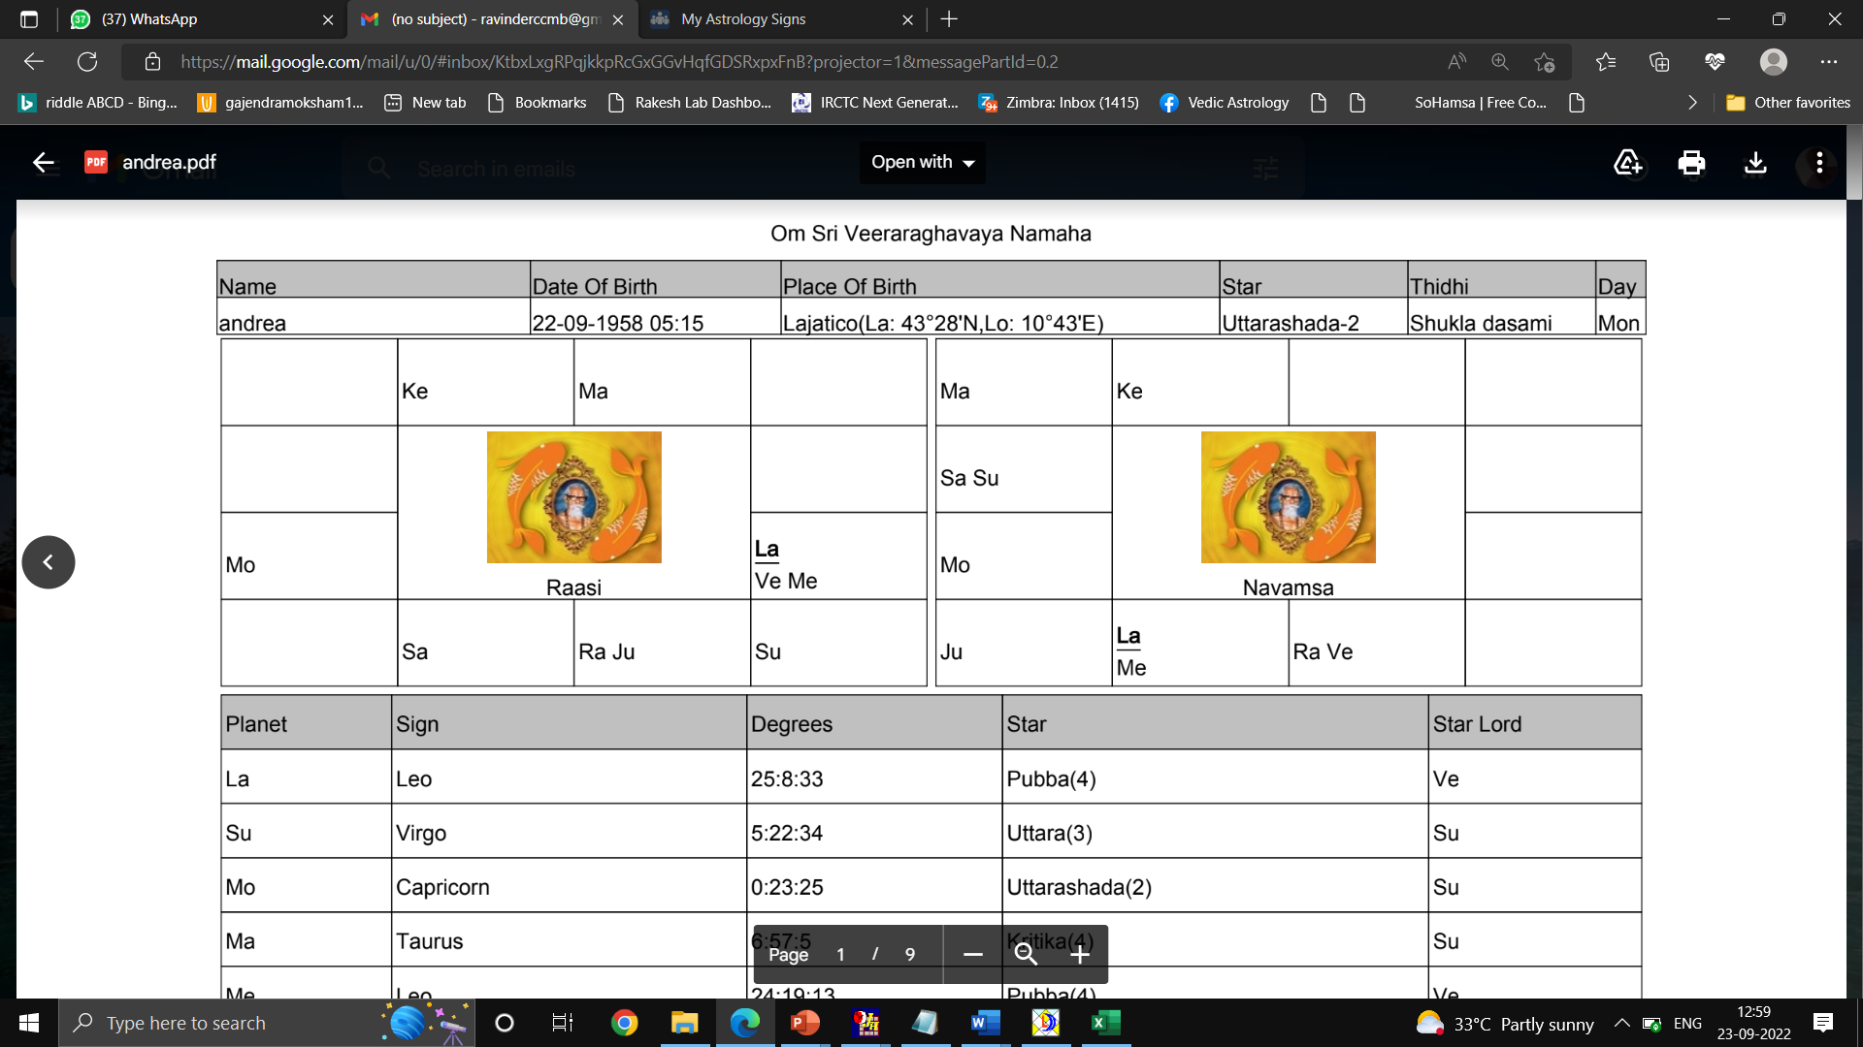

|  |  |  |  |  |  |
| --- | --- | --- | --- | --- | --- |
| **Planet** | **Sign** | **Degrees** | **Nakshatra** | **Qtr** | **Nakshatra Lord** |
| **Ascendant** | Leo | 25 0  08’ | P.Phalguni | 4 | Venus |
| **Sun** | Virgo | 05 0  22’ | U.Phalguni | 3 | Sun |
| **Moon** | Capricorn | 00 0  23’ | Uttarashada | 2 | Sun |
| **Mars** | Taurus | 06 0  57’ | Krittika | 4 | Sun |
| **Mercury** | Leo | 24 0  19’ | P.Phalguni | 4 | Venus |
| **Jupiter** | Libra | 09 0  31’ | Swathi | 1 | Rahu |
| **Venus** | Leo | 22 0  23’ | P.Phalguni | 3 | Venus |
| **Saturn** | Scorpio | 26 0  29’ | Jyestha | 3 | Mercury |
| **Rahu** | Libra | 00 0  06’ | Chitra | 3 | Mars |
| **Ketu** | Aries | 00 0  06’ | Ashwini | 1 | Ketu |

Lagna is Leo and lagna pada is Venus. Venus (3rd, 10th lord) and Mercury 92nd and 11th lord) are in lagna. Lagna is aspected by Mars (4th, 9th lord, Badhaka) and Saturn (6th and 7th lord). Sun lagna lord is in 2nd house in own star and gets connected to lagna through backward binnapada.

Mercury the 2nd lord is in P.Phalguni-4 and in kalamsa of Mercury. Mercury is in star of Venus which becomes Jeeva planet. Venus is in own star so the sign lord Sun becomes Sareera planet. Venus and Sun are enemies posited in 2/12 axis. Venus is aspected by Mars (Badhaka planet) and Saturn (6th lord). Kalamsa lord Mercury obtained RTT gunas. A Satwic Mercury gained major Tamasik gunas.

The karaka for eyes Venus (3rd and 10th lord) is posited in lagna. Venus is in star of P.Phalguni-3 which is kalamsa of Saturn. Saturn is in star of Mercury which is conjunct with stronger Venus which becomes Jeeva planet and Venus is in own star so the sign lord Sun becomes Sareera planet. Venus and Sun are in 2/12 axis. Venus is aspected by Mars (Badhaka planet) and Saturn (6th lord). Kalamsa lord Saturn is in star of Jyestha-3 and obtained SST gunas. Venus a Rajasic planet obtained major Satwic gunas through a tamasic planet.

The karaka for eye sight and health is Sun. Sun is in U.Phalguni-3 in the Kalamsa of Mercury which obtained RTT gunas. Mercury is in star of Venus which becomes Jeeva planet. Venus is in own star so the sign lord Sun becomes Sareera planet. Venus and Sun are in 2/12 axis. Venus is aspected by Mars (Badhaka planet) and Saturn (6th lord). Kalamsa lord Mercury has obtained major Tamasic gunas. Sun a Rajasic planet has attained major tamasic gunas through a Satwic planet.

**3.Ray Charles**

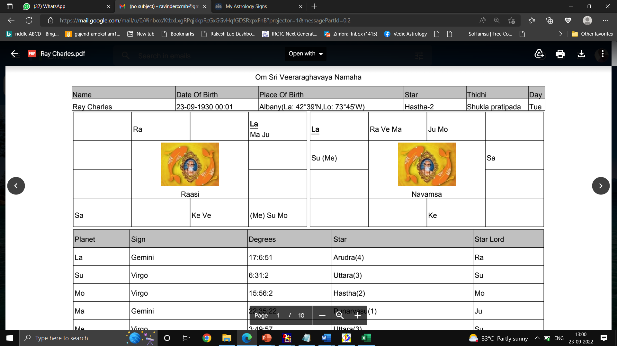

|  |  |  |  |  |  |
| --- | --- | --- | --- | --- | --- |
| **Planet** | **Sign** | **Degrees** | **Nakshatra** | **Qtr** | **Nakshatra Lord** |
| **Ascendant** | Gemini | 17 0  06’ | Aardra | 4 | Rahu |
| **Sun** | Virgo | 06 0  31’ | U.Phalguni | 3 | Sun |
| **Moon** | Virgo | 15 0  56’ | Hastha | 2 | Moon |
| **Mars** | Gemini | 22 0  35’ | Punarvasu | 1 | Jupiter |
| **Mercury** | Virgo | 03 0  49’ | U.Phalguni | 3 | Sun |
| **Jupiter** | Gemini | 24 0  23’ | Punarvasu | 2 | Jupiter |
| **Venus** | Libra | 22 0  23’ | Vishaka | 1 | Jupiter |
| **Saturn** | Sagittarius | 12 0  30’ | Moola | 4 | Ketu |
| **Rahu** | Aries | 02 0  00’ | Ashwini | 1 | Ketu |
| **Ketu** | Libra | 02 0  00’ | Chittra | 3 | Mars |

Lagna is Gemini and lagna pada is Aardra-4. Mars (6th and 11th lord) and Jupiter (7th and 10th lord, Badhaka) are in lagna and aspected by Saturn (8th and 9th lord). Mercury lagna lord is in 4th house in exalted sign and conjunct with Moon (2nd lord) and Sun (3rd lord) and aspected by Saturn and Mars.

Moon the 2nd lord is in Hastha-2 and in kalamsa of Saturn. Saturn is in star of Venus which becomes Jeeva planet. Venus is in star of Jupiter which becomes Sareera planet. Venus and Jupiter are enemies. Venus is in own sign and conjunct with Ketu. Venus is aspected by Jupiter (Badhaka planet). Jupiter is in lagna in own star and gets connected to 2nd house through binnapada. Jupiter is conjunct with Mars and aspected by Saturn 8th lord from badhaka house. Kalamsa lord Saturn obtained TRR gunas. A Rajasic Moon gained major Rajasic gunas through a Tamsic planet.

The karaka for eyes Venus (5th and 12th lord) is posited in 5th house. Venus is in star of Vishaka-1 which is kalamsa of Saturn. Saturn is in star of Ketu which is with stronger Venus which which becomes Jeeva planet. Venus is in star of Jupiter which becomes Sareera planet. Venus and Jupiter are enemies. Venus is in own sign and conjunct with Ketu. Venus is aspected by Jupiter (Badhaka planet). Jupiter is in lagna in own star and gets connected to 2nd house through binnapada. Jupiter is conjunct with Mars and aspected by Saturn 8th lord from badhaka house. Kalamsa lord Saturn obtained TRR gunas. A Rajasic Venus gained major Rajasic gunas through a Tamsic planet.

The karaka for eye sight and health is Sun. Sun is in U.Phalguni-3 in the Kalamsa of Mercury which obtained RTT gunas. Mercury is in star of Sun which is with stronger Mercury also sign lord so Mercury becomes Jeeva and Sareera planet. Mercury is in exalted sign and combust along with Moon. Mercury is aspected by Mars and Saturn (Badhaka planet and 8th lord). Kalamsa lord Mercury has obtained major Tamasic gunas. Sun a Rajasic planet has attained major tamasic gunas through a Satwic planet.

1. **Jean-Paul Sartre**

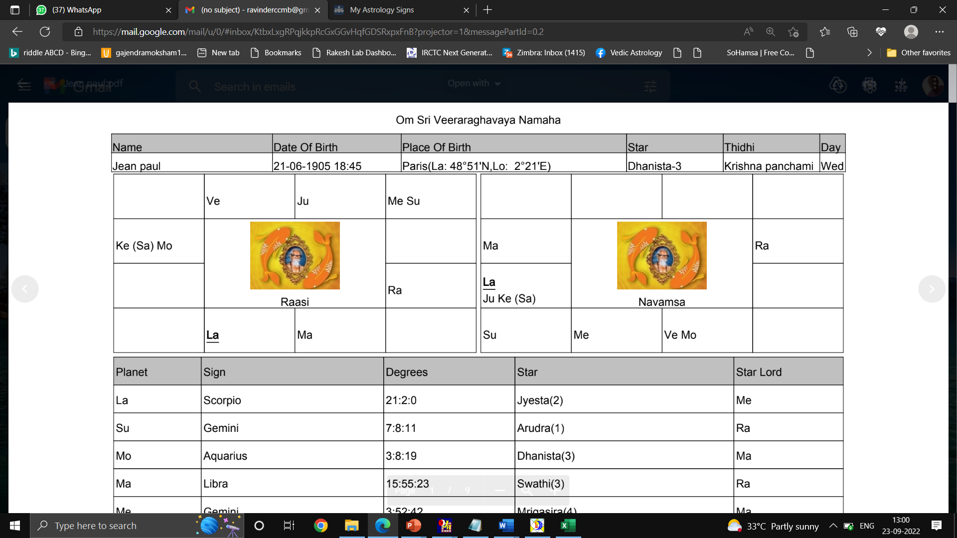

|  |  |  |  |  |  |
| --- | --- | --- | --- | --- | --- |
| **Planet** | **Sign** | **Degrees** | **Nakshatra** | **Qtr** | **Nakshatra Lord** |
| **Ascendant** | Scorpio | 21 0  02’ | Jyestha | 2 | Mercury |
| **Sun** | Gemini | 07 0  08’ | Aardra | 1 | Rahu |
| **Moon** | Aquarius | 03 0  08’ | Danishta | 3 | Mars |
| **Mars** | Libra | 15 0  55’ | Swathi | 3 | Rahu |
| **Mercury** | Gemini | 03 0  52’ | Mrigasira | 4 | Mars |
| **Jupiter** | Taurus | 01 0  43’ | Krittika | 2 | Sun |
| **Venus** | Aries | 22 0  25’ | Bharani | 3 | Ven8s |
| **Saturn** | Aquarius | 10 0  18’ | Satabhisha | 2 | Rahu |
| **Rahu** | Leo | 10 0  49’ | Makha | 4 | Ketu |
| **Ketu** | Aquarius | 10 0  49’ | Satabhisha | 2 | Rahu |

Lagna is Scorpio and lagna pada is in star of Jyestha. Lagna lord Mars is inm12th house in the star of Rahu. Lagna is aspected by Jupiter (2nd and 5th lord) and Saturn (3rd and 4th lord).

Jupiter the 2nd lord is in Krittika-2 and in kalamsa of Jupiter. Jupiter is in star of Sun which is with stronger Mercury which becomes Jeeva planet. Mercury is in star of Mars which becomes Sareera planet. Mercury is in own sign in the 8th house and conjunct with Sun (combust). Mars is in 12th house and is aspected by Venus the 12th lord. Kalamsa lord Jupiter has obtained RTT gunas. A satwic planet obtained major tamasic gunas through a satwic planet.

The karaka for eyes Venus (7th and 12th lord) is posited in 6th house. Venus is in star of Bharani-3 which is kalamsa of Saturn. Saturn is in star of Rahu which becomes Jeeva planet. Rahu is in star of Ketu which is with stronger sign lord Saturn which becomes Sareera planet. Rahu is in Leo sign aspected by Moon (Badhaka planet) and Saturn. Saturn is with Ketu and Moon (Badhaka) in 4th house. Kalamsa lord Saturn has gained TST gunas. Venus a rajasic planet has obtained major tamasic gunas through a tamasic planet.

The karaka for eye sight and health is Sun. Sun is in Aardra-1 in the Kalamsa of Rahu which obtained TRR gunas. Rahu is in star of Ketu which is with stronger Saturn which becomes Jeeva Planet. Saturn is instar of Rahu which becomes Sareera planet. Saturn is with Ketu and Moon (Badhaka) in 4th house. Rahu is in Leo sign aspected by Moon (Badhaka planet) and Saturn. Kalamsa lord Rahu has obtained major Tamasic gunas. Sun a Rajasic planet has attained major tamasic gunas through a tamasic planet.

Conclusion:

It can be concluded that unfavourable gunas of the second house can be linked to eye problems when clubbed with the results of karaka planet for eye. As the other significators of the second house related matters could flourish if the significator of that even is attaining favourable gunas. All native studied had eye problem but still were successful in their life. Its necessary to study the charts with respect to the results of the concerned significator under study.

All the natives’ studies had other important life events to be studied and will be taken up in future study.

**References:**

1. SRS software
2. Stellar Effects-Kalamsa-Gunas, Predictive techniques based on Naadi Principles by Prof NVRA Raja.